News from Fall/Winter 2005

The Devon Nicole House
F O U N D A T I O N

On July 30, 1999 a beautiful healthy baby girl named Devon Nicole came into this world. Five short days later she was called back to heaven. This may sound like the end of a story, but as it turns out, it is just the beginning of a remarkable journey….

Fundraising Events:

Annual Valentines Dinner
February 11th 2006 5:30pm – 11:30pm+
Wyndham Hotel, Andover
Hors d'oeuvres, Balloons, Dinner, and
Silent Auction Event. Tickets available!
LIMITED TO 150 COUPLES. ___________________________
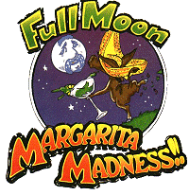
5% of Lounge sales to go to DNH.
Event includes raffles and give-a-ways!
Join us for a HOWLING good time.
DNH REPS=Volunteers NEEDED!
Dates and Locations TBD
______________________________
5th Annual DNH Golf Classic
And celebration of 2 yr Anniversary
Date and Location TBD
*Players and Sponsors welcome!
Ticket includes player gift, LUNCH, golf, cart &fees, cocktail hour, DINNER, raffle and auction event.
VOLUNTEERS NEEDED FOR:
Grant writing, Development and
Event coordination
For more information or to volunteer to HELP, check out our web site.
http://www.devonshouse.org
or call the Foundation office at:
603-594-1385



Margarita’s Restaurants raises over $3000 for
Mission: The Devon Nicole House is a non-profit 501(c)3 charitable foundation dedicated to providing a home-away-from-home for families that have children receiving care at Children’s Hospital Boston. We continue to support The Devon Nicole House at Children's Hospital Boston and look to provide additional help to families in need.
The Devon Nicole House Foundation!
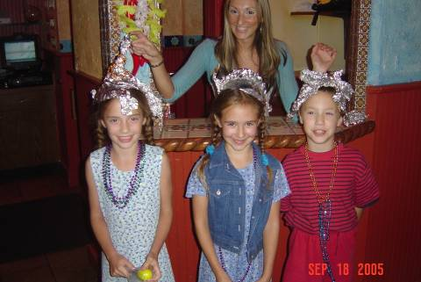
Kaley, Brittany & Justin Missert win prizes for Margarita’s crazy hat contest
Baby Steps .. by Devon’s Dad

First, we wish all of you a Happy, Healthy and safe Holiday season. We also hope that 2006 brings you joy and happiness through out the year. Now, on to some updates.

We had the wonderful opportunity this summer to work with four Margarita’s Restaurants during their Full Moon Madness. Margarita’s and its employees firmly believe that giving back is something that should be done year round. Each month they pick a charity to spotlight and help by raising funds at each of their restaurants. During July, August and September they raised over $3000 for The DNH Foundation. Thanks go to both the Margarita employee’s and the patrons that participated. With your support and through the various fundraisers this year we have been honored to donate more than $30,000 to the operational support of The Devon Nicole House at Children’s Hospital Boston and over $10,000 in DNH Grants to families that have stayed at the House.

The biggest development of the season though is the recently completed makeover of The Devon Nicole House by the truly gifted and big hearted American Society of Interior Designers, a team of volunteers, friends, CHB staff and numerous donors. Words simply can not convey the depth of my thanks for helping to create an even warmer and stronger feeling of HOME at the House. You gave from your hearts to families you may never know. Your generous spirit and talent are reflected in every detail of your work. Thank you. (See preview pictures inside.)

This year we began to focus on the DNH Foundation Grant program. As you will see inside this newsletter, the effects that this program has had on families have not only touched their lives, but also helped to inspire us to work even harder to help other families.

The journey continues. We thank all of you again for your support. Without you, we could not reach out to help so many others. Please stay involved! Right now we are actively looking for 2 new Trustees, and volunteers to help us with Grant Writing and Development. We also need several volunteers to help with the upcoming Valentine’s Dinner. If you would like to help, please contact tom@devonshouse.org or call us at (603) 594-1385.

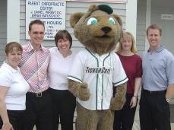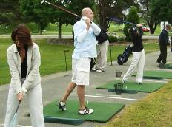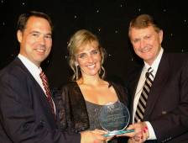
2005 Kid’s Day America 4th Annual DNH Golf Tournament Carleton Sheets & DNH Founders
Parent Chiropractic Staff and Fungo Golfers drive to raise $11,000 for DNH Recognition award from DNH friend

Kids Day USA – On May 14, 2005, Parent Chiropractic Center hosted its fourth Annual “Kids Day America.” This was a day dedicated to children’s health and safety awareness. Events included fire safety, dental identification imprints, talks about karate and self defense, and some just for fun activities like face painting, crafts, massages and more. FUNGO from the Manchester Fisher Cats also made an appearance to help. The success of such an event is directly related to the effort of its volunteers. This year the event raised over $1500 for The Devon Nicole House Foundation. We’d like to thank Parent Chiropractic, their staff, and all the businesses and volunteers that made this years event the best yet. THANK YOU.

4th Annual DNH Golf Tournament – This years Golf Tournament raised $11,000 for The Devon Nicole House. A field of 120 players teed off under a cool June breeze and had a very good afternoon at the Sheraton Ferncroft Country Club. Both the lunch and dinners were delicious. The silent auction and awards capped off the evening. This year’s 1st Place Team was from Children’s Hospital Boston. (Dr. David Fulton, Glenn Stewart, Gary Horne, Greg Drummer) Please check out the DNH website for details of next year’s event!

Carleton Sheets Award – Long time DNH supporter and friend Carleton Sheets took time to recognize several of his students at a September awards banquet in Naples, Florida. Among the awardees were DNH founders Thomas and Deanna Missert. Special thanks go to both Carleton and his staff at The Professional Education Institute (PEI) who early in July made a very generous donation to The Devon Nicole House Foundation.
Advisors to the Board:

Dr. Jim Lock Physician-in-Chief and Chairman, Dept of Cardiology Children’s Hospital Boston
Dr. Kathy Jenkins Cardiologist, Children’s Hospital Boston
Susan Shaw Director Clinical Operation, CHB
Cynthia Levin Director Center for Family Services CHB
Scott Neely Executive Director, Neely Foundation
Ian Hoenisch CTO, ESP Technologies
Dick Cyr President of David’s House, Lebanon NH
Laura Sol Sr. VP, American Heart Association
Vinny Harte Director, Wellspring Inc, Hull MA
Suzanne Mooney former Board Member of Jason’s Place
Dean Ouellette High Street Communications
Santa Sasena Price Waterhouse-Coopers
Dr. Anne Jacoby Cardiovascular Nurse Specialist
Paul Henry American Express Financial Advisor
Tracy Jenkins Special Events Assistant
Jae-Ann Rock Development and Events
Richard Defalco Former member of DNH Board
Karen McHugh Former member of DNH Board

Memorial donations in loving memory of:
Nathan Cummings Christian Kelly Clare Elizabeth Ettrick
Janet Huminski Olivia Joy Tarquinio Robert Carr
Lucas Richard Dalke Daniel Joseph Hyatt Katelyn Rose Pacheco
Mary Perkins Bernice Smith Theodore Cotrupi
Eileen Keefe Adam Bryce Craig Anna Grace Garafola
Darrell Dupree Thomas Allen Abbott III (Tripp) Muriel Tyler

Donations in Honor of the following people:
Jacob McDonald Paige Aitken Lauren Allen
Shane Mulcahy Elizabeth Allen
Barry Condron John & Linda Callahan

To all those that have donated their time, prayers, money and support..please know you make a difference. From the families and DNH Foundation Trustees
THANK YOU!

AMAZING MAKEOVER!

The Devon Nicole House at Children’s Hospital Boston and the families that stay there received an early Christmas present the first week of December. The American Society of Interior Designers (ASID) teamed up with Children’s Hospital staff and hundreds of volunteers to make The House even more of a home to the families that need to stay at the house while their children are being treated at Children’s Hospital Boston. The transformation was truly amazing and was miraculously accomplished in one short week. The rooms reflect the hearts, love and beauty of each and every person that worked to make this gift a reality. Thank you.

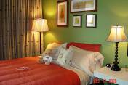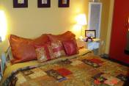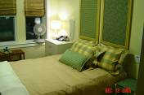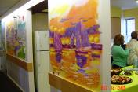
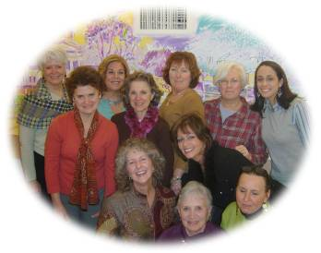
Faces of some of the ASID team that designed from the heart.
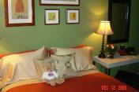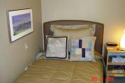

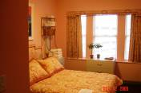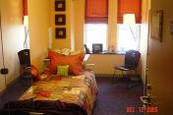

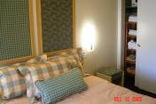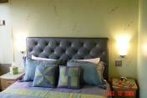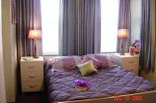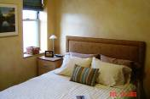

To ASID, your friends, donors and all those involved, THANK YOU!!
We greatly appreciate the work, time, and effort spent on this amazing makeover.

Faces of Thanks
2005 Recipients of DNH Foundation Grants

Below are some of the children’s whose lives you have touched through your generous support of the Devon Nicole House Foundation and the Grant Program. We have spoken with each family, and from them we express a simple message, “Thank You.”
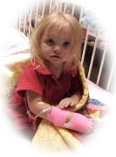
Trinity
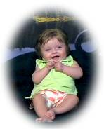
Kylie
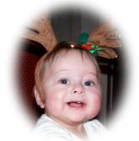
Kallie

“It was truly a blessing. Devon Nicole story is truly amazing and touched our hearts. We sincerely thank you for this gift and for all that you have done and continue to do for others.”
The White Family, NY

“This is a wonderful Holiday surprise. This money is going to help out my little family tremendously. . It's wonderful people like yourself and the people at Strong Hearts that are able to give parents like Denis and I a little boost.”
The St.Peter Family, ME

“Thank you so much for your help. We look forward to meeting you someday. We also hope to attend the Valentine's Dinner”. The Mulvihill Family, CT
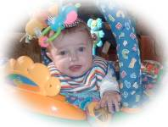
Bryce
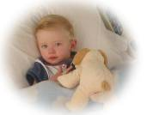
Nico
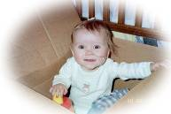
Megan
The Devon Nicole House Foundation Grant program was established by the Foundation Board of Trustees after The Devon Nicole House at Children's Hospital Boston opened. These Grants are primarily intended for families that have stayed at The Devon Nicole House at Children's Hospital Boston. We hope to help those families by providing small grants to help with uncovered and unexpected expenses. With your help and support we hope to expand and grow the DNH Foundation Grant program.

Grant applications and more information are available online at: www.devonshouse.org
or you may call the Foundation office at (603)594-1385.

If you’d like to support the Grant program, please call or email us at: tom@devonshouse.org

You are cordially invited to attend the
6th Annual Valentines Charity Dinner
for The Devon Nicole House

Saturday, February 11, 2006



Location: Wyndham Hotel, Andover MA.
Main Ballroom.

Event: Romantic and Elegant Valentines Dinner plus Silent Auction.
Charity event with proceeds to help us support
The Devon Nicole House Foundation

Price includes: 5:30pm-6:30pm Reception with Hors d'oeuvres. Balloon sales.
6:30pm-11:30pm+ Formal dinner, drinks, entertainment,
dancing and entrance to the Silent Auction.

Pricing: Seating is $75 per plate. Tables seat 8-10 people.
Corporate Sponsors are needed. Please call us for details.

__________________________________________________________
Please contact us if you are interested in Tickets. Call (603)594-1385 OR fill out this form and send it to us.
Please FAX this page to
(603)594-8849
OR
If paying by check, mail to:

Devon Nicole House
PO Box 901
Londonderry NH 03053

We will call to confirm.
Thank you for your support!

Payment (circle one): Visa –MasterCard - Check

Please Print
Name as it appears on card ______________________________________________

Billing address________________________________________________________

____________________________________________________________________

Telephone: (________)__________________________ Number of tickets _____

Email: ______________________________________ Total: ___________

Card Number___________________________________________ Expiration______________ CCID _______

I authorize DNH to debit my card as specified above____________________________________ (Signature required)

(* If you can not attend but would like to make a donation, please list pledge here $________ and FAX us this form)

OR Log on to our website for event details, directions, or more order forms: www.devonshouse.org


The Devon Nicole House Foundation
PO Box 901
Londonderry NH 03053
PRESORTED STANDARD
POSTAGE & FEES PAID
LONDONDERRY, NH
PERMIT NO. 60

To:

DNH Foundation Critical Needs:
- Financial donations at all levels
- 2-3 volunteers to help with Grant writing
- 2 new members for DNH Board of Trustees
- Volunteer to help with fund-raisers
- Continued Prayers
- Annual Endowments for on going operational costs to support DNH and the Foundation Grant Program
- Members for Advisors to DNH to provide on going support and guidance to the Board of Trustees
- DONATED ITEMS FOR SILENT AUCTION
for Valentines Dinner, February 11th 2006
AUCTION IDEAS: Event tickets, RCI vacations, autographed sports memorabilia, dinner gift certificates, golf lessons, quilts, TV, digital camera, gift baskets etc.
NEWS INSIDE:
Amazing Makeover
Faces of Thanks
Valentines Dinner Ticket Order Form

