News From The Devon Nicole House

Fall 2004

PO Box 901 http://www.devonshouse.org
Londonderry NH 03053 Fall 2003

On July 30, 1999 a beautiful healthy baby girl named Devon Nicole came into this world. Five short days later she was called back to heaven. This may sound like the end of a story, but as it turns out, it is just the beginning of a remarkable journey….

Fundraising Events:

CIBC Miracle Day
December 1st 2004

See details inside on how you can help!
5th Annual Valentines Dinner
February 12th 2005 5:30pm – 11:30pm+
Andover Country Club.
Hors d'oeuvres, Balloons, Dinner, and
Silent Auction Event.
Tickets paid by Jan 1st will be entered into a raffle for secret gift.
Kid’s Day USA – May 15, 2005
Benefit Concert – May 2005
Details are still in the works. See website for updates/details.
4th Annual DNH Golf Classic
Thursday June 16th 2005, 12:15pm
Ferncroft Country Club!!
*Players and Sponsors needed!
Ticket includes player gift, LUNCH, golf, cart &fees, cocktail hour, DINNER and auction event.

For more information or to volunteer to HELP, check out our web site.
http://www.devonshouse.org




Kids crowd DNH at CHB lounge at Open House !
Mission: The Devon Nicole House is a non-profit 501(c)3 charity dedicated to providing a home-away-from-home for families that have children receiving care at Children’s Hospital Boston. We will continue to support The Devon Nicole House at Children's Hospital Boston and look to provide additional help to families in need.
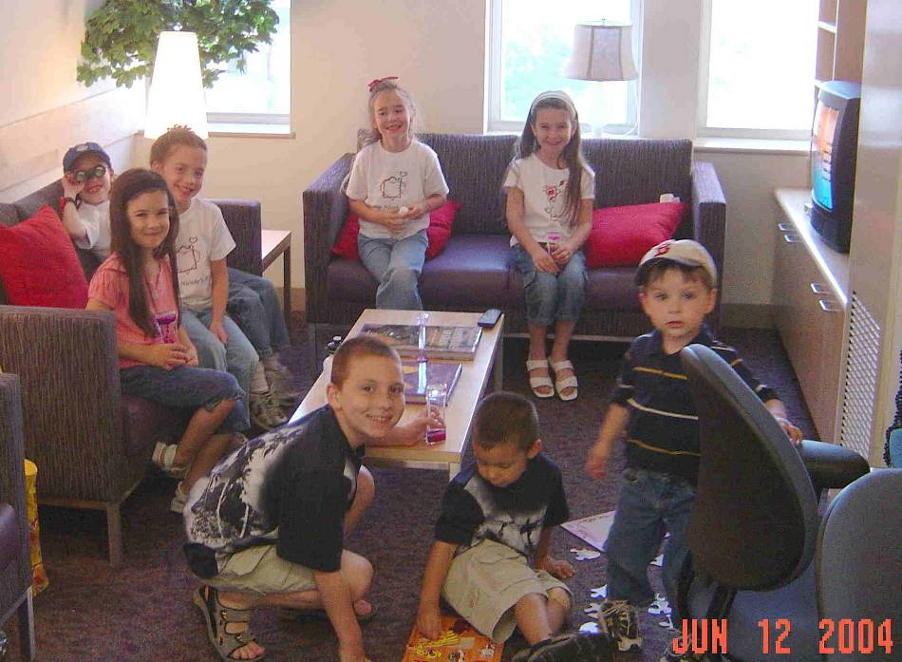
Baby Steps .. by Devon’s Dad

The holiday season is upon us. We wish you ALL a safe and happy holiday season. We also give thanks to ALL the DNH Friends and Children’s Hospital Boston staff that made 2004 such a memorable year. On June 14th 2004, we celebrated the realization of a dream. The Devon Nicole House at Children’s Hospital Boston opened their doors and hearts to patient families. In the first 5 months 129 families not only had a place to rest, but also a home where they formed new friendships with other families and staff at the House.
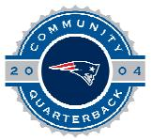

On one Wednesday night we had a chance to get together with some of the DNH at CHB volunteers and families staying at the House. We met a family from Albania, another from Maine and one from Tennessee. They all had touching stories to share, some of the laughter and even some of the tears that we shared help to lighten the load. We wish we could convey to you how much your support of DNH has touched the lives of these families. They were overwhelmed and truly thankful for the opportunity to stay at the House.
Devon Nicole House invited to participate in NFL 2004 Community Quarterback Awards program by The New England Patriots & The Kraft Group

As we move into 2005 we are very excited about the growth that will take place both at the House and within DNH. We hope to help create a true sense of family and home by reaching out to help families and their children in new areas. The original vision Devon gave to us was simply to help families and their children. Once the house was opened we knew that there would be other areas that we might be able to help.

As the word spreads and DNH Friends continue their heart filled support, we will expand to help cover some of the unexpected costs that families face. These may range from something simple like phone cards and meal gift certificates, to bigger costs like helping with travel or un-covered medical expenses. Truly we hope to foster the feeling that yes, DNH at CHB is a home, but we are also a family. And family does what they can to help their own.

The journey continues. We thank all of you again for your support. With out you, we could not reach out to help so many others. Please stay involved! We will need your continued support to continue our work. Right now we are actively looking for 2-3 new Board members and someone to volunteer as Director of The DNH Coffee Club. We also need several volunteers to help with the up coming Valentine’s Dinner. If you’d like to help, please contact tom@devonshouse.org or call us at (603) 594-1385.

Multiple Fund-Raisers all help DNH continue to help others!

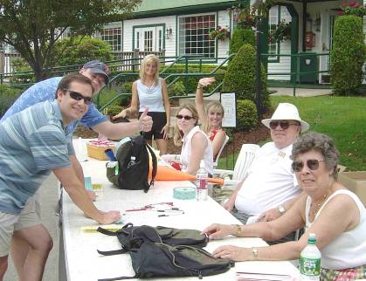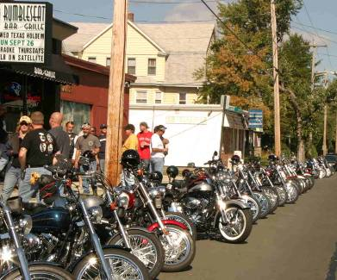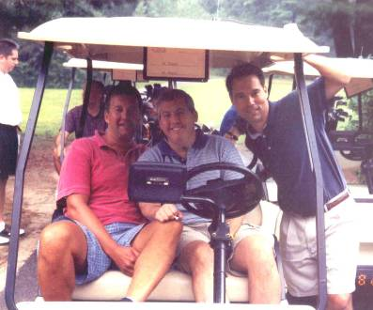

3rd Annual DNH Golf Classic 1st Annual Poker Run Jeffrey Lucier Memorial Golf Tournament
At The Sheraton-Ferncroft Country Club Sponsored by: Rumbleseat Sponsored by Kevin & Cindy Mairs

3rd Annual DNH Golf Classic –June was a busy month. Three days after the opening of DNH at CHB over 100 DNH Friend crowded the fairways for the Annual DNH Golf Classic. This year’s format was a Thursday afternoon outing at the Sheraton-Ferncroft Country Club that included lunch, dinner and an auction event. Thanks go out to all the volunteers that helped make the event run so smoothly this year. Especially Tracy Jenkins, DNH at CHB Project Manager Jennifer Darling, Betty Missert (all shown manning the reception table above), Polly Allyn, and of course all our Board of Trustee members! Thank you also to the players and sponsors who helped to raise over $7000 this year!!
Please join us next year on June 16th, 2005 back at the Sheraton-Ferncroft CC.

1st Annual Poker Run – On a BEAUTIFUL Sunday afternoon, Sept. 26th, a big-hearted group of over 100 people cruised through the 1st Annual Poker Run. The final cards on the 85-mile run were drawn at the sponsoring Rumbleseat Bar and Grill located in Chicopee MA. Thank you to all participants!

Jeffrey Lucier Memorial Golf Tournament – Can you say MONSOON?! Torrential rains in the morning lead to soggy conditions for the 40 golfers who teed off at noon. The afternoon rains held off for all but the last few holes. (That’s when the heavy stuff really started.) This was a true test of a golfers fortitude and dedication to the sport of golf. Special thanks go to Cindy & Kevin Mairs who organized the entire event. Thanks also to all the players, sponsors and families that came out to support the event and helped raise $3400!
Board of Trustees:
Thomas Missert Devon’s Dad, President Tomm@devonshouse.org
Deanna Missert Devon’s Mom, VP Deanna@devonhouse.org
Ruth Adams Senior Member, &Treasurer Ruth@devonshouse.org
Jennifer Pontzer Senior Member, Board of Trustees Jennifer@devonshouse.org
Denise Tarquinio Senior Member, Board of Trustees Denise@devonshouse.org
Margaret DeSantis Senior Member, Board of Trustees Margaret@devonshouse.org
Gene McGraw Senior Member, Board of Trustees Gene@devonshouse.org
Karen McHugh Senior Member, Board of Trustees Karen@devonshouse.org

Advisors to the Board:
Dr. Jim Lock Physician-in-Chief and Chairman, Dept of Cardiology Children’s Hospital Boston
Dr. Kathy Jenkins Cardiologist, Children’s Hospital Boston
Susan Shaw Director Clinical Operation, CHB
Cynthia Levin Director Center for Family Services CHB
Scott Neely Executive Director, Neely Foundation
Dick Cyr President of David’s House, Lebanon NH
Laura Sol Sr. VP, American Heart Association
Vinny Harte Director, Wellspring Inc, Hull MA
Suzanne Mooney former Board Member of Jason’s Place
Dean Ouellette High Street Communications
Santa Sasena Price Waterhouse-Coopers
Dr. Anne Jacoby Cardiovascular Nurse Specialist
Paul Henry American Express Financial Advisor
Tracy Jenkins Special Events Assistant
Jae-Ann Rock Development and Events
Richard Defalco Former member of DNH Board

Special Thanks to Alicia Daigel the current Resident Advisor (RA) who helped to lay the foundation for operations at the House will be stepping back to a part-time role. We appreciate the work that she has done and her continued help. Thank you Alicia!

CIBC Miracle Day
December 1st 2004

The Devon Nicole House has been offered an incredible opportunity to participate in CIBC World Markets Miracle Day. Since its inception in 1984, Miracle Day has become an annual tradition for CIBC World Markets. On Miracle Day, CIBC World Markets donates an amount equal to all of the day's fees and commissions raised to children's charities around the world.

To leverage the event and help DNH continue to help and serve families and their children we need your help. If you work at or have contacts within a financial firm that trades stocks, mutual funds or hedge funds, please contact us! (603-594-1385 or email tom@devonshouse.org). Details are also on our website at www.devonshouse.org
….Simple explanation….
We need traders to designate Devon Nicole House as charity of choice with their CIBC rep for Miracle Day.


We have had several DNH Friends ask if there is a way to donate to DNH through their company sponsored United Way campaign. After making several calls.. the answer is YES!

The process is simple.
When you fill out the United Way campaign pledge form at work, there is a place on most forms to write in a specific 501(c)3 charity that you would like to donate to. Simply write in:
Devon Nicole House, PO Box 901, Londonderry NH 03053.
If there is room or if it is required, you may provide our tax id : 02-0517710

Save time(good), Save money (better), Save & Donate (GREAT!)
H&R BLOCK

H&R Block is one of the most nationally recognized tax preparation services. Their trained experts will help you save time and MAXIMIZE your tax return potential.

H&R Block has offered DNH Friends a great opportunity. Any NEW client that goes to any H&R Block office with a Devon Nicole House Referral Form will receive a check for $10.00 as a thank you for coming to H&R Block as a new client AND help DNH receive a $20 donation from H&R Block. DNH Referral Form is available on-line on our Fund Raising page at: www.devonshouse.org OR contact us and we can email/fax a copy to you OR your H&R Block representative. Tom@devonshouse.org or call (603) 594-1385

You are cordially invited to attend the
5th Annual Valentines Charity Dinner
for The Devon Nicole House

Saturday, February 12, 2005




Location: Andover Country Club, Andover MA.
Main Ballroom.

Event: Romantic and Elegant Valentines Dinner plus Silent Auction.
Charity event with proceeds to help us support
The Devon Nicole House at Children’s Hospital Boston.

Price includes: 5:30pm-6:30pm Reception with Hors d'oeuvres. Balloon sales.
6:30pm-11:30pm+ Formal dinner, drinks, entertainment,
dancing and entrance to the Silent Auction.

Pricing: Seating is $75 per plate. Tables seat 8-10 people.
Corporate Sponsors are needed. Please call us for details.

__________________________________________________________
Please contact us if you are interested in Tickets. Call 888-594-8354 OR fill out this form and send it to us.
Please FAX this page to
603-594-8849
OR
If paying by check, mail to:

Devon Nicole House
PO Box 901
Londonderry NH 03053

We will call to confirm.
Thank you for your support!

Payment (circle one): Visa –MasterCard - Check

Please Print
Name as it appears on card ______________________________________________

Billing address________________________________________________________

____________________________________________________________________

Telephone: (________)__________________________ Number of tickets _____

Email: ______________________________________ Total: ___________

Card Number_________________________________________________ Expiration__________________

I authorize DNH to debit my card as specified above____________________________________ (Signature required)

(* If you can not attend but would like to make a donation, please list pledge here $________ and FAX us this form)

OR Log on to our website for event details, directions, or more order forms: www.devonshouse.org

The Devon Nicole House Coffee Club

Join the DNH Coffee Club for just $1 a day!
We will deliver your DNH Coffee Mug and complimentary bag of Starbucks coffee. Please choose RED or BLUE for mug color. Coffee Club members receive 10% off all DNH events AND will receive additional surprise coffee club gifts throughout the year.

I want to pledge an annual contribution of $1 per day for one year. ($365 for the full year)

I want to contribute (circle one): Monthly $30.42 Quarterly $91.25 Annually $365

Please FAX this page to us at 603-594-8849 if you are interested. We will call you to confirm. Thank you for your support!
4th Annual Charity Golf Tournament for
The Devon Nicole House

Thursday 12 pm June 16th 2005
DAYS EVENTS
Sheraton-Ferncroft Country Club, Danvers MA 12:00pm Registration opens.
$200 fee covers the entire event including: Golf range open. 1 Free bucket
Lunch, 1 bucket of balls at the range, greens fee & cart 12:30 –1:30pm Lunch
player's pack (5 raffle tickets and player gift) 1:30 pm Shotgun start, BRAMBLE PLAY
and dinner. 5:30– 6:30pm 19th Hole. Reception/Cocktail Hour
1pm-7pm Silent Auction
6:30pm-9pm Dinner, awards and update on DNH.

Directions, Player registration and SPONSOR forms are available on the website.

Circle one: Single: $200 Pair: $400 4-Some: $800 Other: $________ Sponsor: CALL ME
I am interested in (circle one or BOTH) : Golf Tournament DNH Coffee Club ( RED or BLUE )

Payment (circle one): Visa – MasterCard - Check Total: _____________
Please FAX this page to
603-594-8849

We will call to confirm.
Thank you for your support!

Please Print
Name as it appears on card _______________________________________________

Billing address__________________________________________________________

_____________________________________________________________________

Telephone: (________)_______________________ email: _____________________________________

Card Number__________________________________________________ Expiration__________________

I authorize DNH to debit my card as specified above____________________________________ (Signature required)

Devon Nicole House Donors (from November 2003 – November 2004)*

FOUNDERS ($10,000+) | BENEFACTORS (cont.) | ASSOCIATES (cont.) | ASSOCIATES (cont.)
Anonymous (2) | Paul & Carolyn Missert | Lois Crandell | Jim and Millie Pack
Boston Children's Heart Foundation | Jim & Mary Missert | David Delconte | Dan & Dawna Parent
Victor Garciapara for | Michael & Karen Moran | Janice Denninger | Randy & Sue Pearsons
Nomar 5 Fund, Inc. | Richard & Lucienne Norman | Kelly Dennis | Kim Pinet
Jim Lock, Children’s Hospital | Larry & Louise Panzeri | Quintin Depina | Louis & Beth Poulo
CHMC Cardiovascular  Surgical Foundation | RBC Dain Raucher | Marc & Liza Dicosimo | Russell & Susan Quinn
Thompson Family | Bryan & Heather Schenck | Kenneth Dubois | Quota Club of Andover
 | Stonehill College | Jack & Kelly Dvareckas | Quota Club of Portsmouth
DIRECTORS ($5,000-9,999) | - campus ministry | Lorraine Elwood | Rain or Shine
GE - Good Neighbor Fund | Jay Sweeney | Joseph & Judith Federico | Matthew & Alison Richards
Massachusetts Elks Assoc |  | David & Margaret Fleming | Mitchell & Lisa Robillard
Scott Desantis RE/MAX Nashua | PATRONS ($250-499) | Robert & Judith Flores | Gary Rocca
Pricewaterhouse Coopers | Amherst Junior Women's Club | Joe Fratus | Bernie & Anne Rozmovits
 | Ardell Bartolotta | Kevin & Mary Frey | Bill Rugg
EXECUTIVES ($1000-4,999) | Our Lady of Victory Elementary School | Josef Fryer | Samuel & Ann-Marie Sacco
Anonymous (2) | Steven Clancy | Jamison Gagner | Michael & Laura Scanlon
Glenn & Brenda Bach | Norm Cloutier | John Ganley | Silver Shears
Martin Batt | Kiwanis Club of Hudson | Chris & Lori Gardner | Carlton & Allison Stallings
Anthony & Madeline Berni | Peter Coffin | Paul & Ellen Gelep | Shepard & Marlene Stone
Michael Christian | Doug & Cindy Cummings | Pete & Dorothy Goal | John & Patricia Strosnick
Jennifer Connor | Neil & Michelle Grice | Michelle Goldthwaite | R.D. Swanson
Michael Costello | Rosemarie & Paul Hatin | Robert & Gertrude Goodwin | Joseph & Marie Sweeney
Matthew & Paula Dalke | Deb Hewitt | George & Sue Gormandy | Matthew & Laura Therrien
Fidelity Charitable Fund | Regina Languin | Kevin Grassa | Kevin & Joann Thorton
Patricia Hickey | John & Amy Lee | John Hagigeorges | Colleen Tormey
Islington Community Church | Donald Martin | Edward & Donna Halloran | Stephen & Linda Toth
John the Evangelist Church | Chuck & Karen McHugh | Paul & Cathy Hamilton | Owen Walton
Brian Leclerc | Karlyn Paolella | Aimye Haroutunian | Dan & Andrea Warriner
Loh Family Charitable Gift Fund | Greg & Tina Quercia | James & Sharon Harper | Hal & Terry Weygandt
Londonderry Rotary | Robert & Margaret Romeo | Gordon Hay | Consuelo Wilches
Cindy & Kevin Mairs | Michael & Kathleen Rosen | George Hetrick | Gary & Susie York
Patricia McCabe | Edward & Santa Sasena | Mindy Horwitz
Gene & Ruth McGraw | Mark & Jill Tennison | Roy & Kristi Hunter | FRIENDS ($1-99)
Leo & Patti Mullin | Andrew & Beth Violette | Tracy & Darryl Jenkins | Tom & Lisa Abbott
Brian & Marci Palmer | Elise Woiszwillo | Russell & Evelyn Keller | Armen & Mary Abrahamian
Edmund & Marie Poirier |  | Robert & Dawn King | Fred & Mona Afshar
Putnam Investments | ASSOCIATES ($100-249) | Wayne & Christa Koch | Richard & Alice Allen
Stronghearts | Timothy Adams | Jason & Sarah Lacroix | Anonymous
 | Therrin & Katherine Allen | Reed & Kathy Landmark | Carl & ElizabethAustin
BENEFACTORS ($500-999) | Pauline Anton | Boonsri Laoteppitaks | Thomas & Mary Bearor
Dana Ahern | Alan Arcadipane | Candice Lawrence | William & Janet Beck
Charles & Kathleen Alexander | Amy Austin | Sherri L'Ecuyer | Frankie Benjamin
John & Pauline Allyn | William & Catherine Barger | Jim Lombardo | Knud & Margaret Berge
Anonymous (2) | Mary Barry | Philip & Georgia London | Charleen & Barrett Bertolini
LHS Associates | Keith Beaudin | Christine McGinn | William & Anne Bishop
Richard Bernard- | John & Robin Beecher | Saundra Maisey | James & Janet Blackman
and House of The Samurai | John & Barbara Beecher | David & Deborah Malone | Jim Blanton
Candia Youth Athletics Ass. | Richard Belanger | William Mariano | Stephen & Rosalie Blunden
Knights of Columbus #6850 | Peter & Barbara Bell | Kevin & Meghan McGuire | Henry & Maryann Bonk
Anthony & Nicole Constabile | Kevin Bickford | Fred & Linda McManus | Janine Brummer
Curves of Pelham | Everett & Donna Bishop | Thomas McPherson | John & Susan Bunker
Ronald Dalke | Peter Bronstein | Stephen & Catherine Mercier | Kathy and Ron Butler
Devine Millimet & Branch | Bill and Sue Burns | Sean Merritt | Frank & Debbie Butterworth
Andrew & Donna Dunn | W. Buss | Thomas & Betty Missert | Yanneth Camp
James Faro | Bruce Carmichael | Braggables/MJ Mitchell | Robert & Marie Campbell
Jack & Kelly Ganley | Tony & Beverly Cheek | Mark & Lietza Molloy
Jack & Marjorie Izzo | Carrie Clark | Charlie & Debra Morse
Richard Jean | Frank & Carol Citrone | Joel Olbricht | * We apologize if we missed
Eric & Lisa Johnson | Stephen & Marsha Cohen | Dean & Jessica Ouellette | anyone due to printing
Doug & Kim Kinz | Kelly & Debbie Collins | Kevin & Meghan McGuire | deadlines or for any errors on
LPC | Peter Collins |  | our part.
Tim McDonald

Devon Nicole House Donors (from Nov. 2003 – Nov. 2004)* (continued)

FRIENDS ($1-99) | FRIENDS (cont.) | FRIENDS (cont.) | FRIENDS (cont.)
Randi-Ann Carlone | Christopher & Cheryl Grant | Joan McQuillan | John & Louise Shepard
Paul & Suzanne Carlson | Jason & Leanne Greene | Bernard Michaels | Charles & Martha Shugrue
Julie Carey | Rita Greska | Denyse Miller | Jeremy & Corinne Smith
Stephen & Rosemary Castonguay | Hugo & Adriana Gutierrez | Charles & Elizabeth Miller | Raymond & Judy Smith
Debra & Marc Caverly | Louise Hall | Brittany Missert | John Sorenson
James & Linda Chiaraluce | Donald & Frances Hedlund | Kaley Missert | Silvino & Dorothy Sousa
Nancy Clark | Emmet & Ann Hibson | Justin Missert | Walter & Connie Southard
Richard & Jennifer Condon | Warren & Marion Higgins | Corinne Modugno | Wade & Karen Sprague
Angelo & Elvira Consolo | Patricia Hines | Jack & Marilyn Mohan | David Stenberg
Matthew & Janice Coyle | Edwin & Margaret Hinrichs | Patrick Morgan | Chip & Nina Sutton
Amy Crockett | Allan & Lynn Hock | Tricia Mottram | C. Arnold Swanson
Paul & Pamela Crowley | Brendan & Lisa Hoffman | Richard & Judith Mumaugh | LLC Synergistic Therapies
Stanley & Jean Cummings | John & Tracy Hogan | Ryan & Erica Murphy | Sherry Szczawinski
Ken & Paula Cummings | Marybeth Holland | Robert & Pauline Nelson | Steve & Denise Tarquinio
Bruce & Meg Cummings | Diane Horan | Douglas & Rebecca Nolan | Greg Titus
Raymond & Gail Curren | John & Susan Hughes | David & Karin Norris | James & Debra Toland
Larry & Linda Cutter | Velcro Inc. | Marge O'Neil | John & Joan Tomer
William & Marjorie Dachtera | James & Michele Jellison | John Pasquale | Vincent & Cathy Vellucci
Patricia Daly | Vernon & Kristine Jenkin | Ed & Bobbie Paul | Carolyn Wagoner
Harold & Ellen Danser | Paula Joy | Margaret Pelczar | Henry Wallace
Marilyn Deluca | Dan & Pamela Kaiser | Bev Pelosi | Bruce & Patricia Webber
Brynn Demas | Henry & Winn Kennedy | Jack & Joan Perry | Joseph & Elaine White
Joseph & Kathleen Deponte | Kim Kerns | Clark & Kay Peters | Donald & Dorothy Whitten
Stacy Derderian | Stephen & Mary Keville | Rick & Beth Petrie | John & Cindy Windsor
Anne DeWolfe | Paul & Stacy Kinnaly | Gene Philbrick | Kristen Withers
Pam & Brian Dodge | Seymour & Sandra Kofsky | Rob & Laura Riker | John & Mary Woods
Fran Donovan | Harriett Kulick | Mark & Cathleen Ristaino | Yale School of Medicine
Peter & Marianna Doulamis | Charles & Pam LaBove | Stephen Romano | Lisa Young
Michael & Mary Dubois | Russell & Michelle Lecaroz | Steven & Alison Rosen | William & Louise Zemina
Paul & Andrea Duffy | Bruce & Nancy Lewis | David & Meghan Rosso | Maritza & Imad Zrein
Dal Dumars | Hansen & Carolyn Long | Mr & Mrs Rosso
Bob & Kathy Eamiello | Emery & Rose Lucier | Deborah Roth
Dan & Anne Edmondson | Julie MacRae | Terry & Susan Rudy
Joseph & Diane Erdos | Marion Maney | Daniel & Heidi Russell
Jamene Farrell | Roberta Marianella | Barbara Russo
Coreylee Feltovic | Cindy Matthews | Robert & Cozette Sanderson
Leonda Fermo | Kerry McCarthy | Cathy Sanford
Arthur & Susan Fisher | Dennis & Carole McCartney | Paul & Alma Sartori
Bruce & Dianna Frick | William & AudreyMcCrea | Rebecca Schiefer
John & Jaqueline Gardiner | Al & Janet McEachern | Martin & Lynda Schmidt | * We apologize if we missed
Stuart & Jane Goldstein | John & Maureen McGonagle | Jim & Aud Segalini | anyone due to printing
David Gordon | Grace McIntosh | Jordan Shapiro | deadlines or for any errors on
Susan Grajek | James & Joan McPartland | Dave & Linda Sheasley | our part.

Special Thanks to people giving gifts in kind…
LPC Women – for Thanksgiving dinner and multiple lasagna and other delicious meals
Miranda McDonald at the Polishing Touch – for her food drive
Nancy Metevier and Knights of Columbus Council (#685) of Raymond NH -for donating needed lotions, soaps, toothpaste etc.
Donations made in honor of…
Elizabeth Marie Allen’s
1st birthday

Memorial donations were given to DNH in loving memory of:
Nathan Cummings Devon Nicole Missert Clare Elizabeth Ettrick
Janet Huminski Olivia Joy Tarquinio Robert Carr
Lucas Richard Dalke Daniel Joseph Hyatt Katelyn Rose Pacheco
Mary Perkins Bernice Smith Thomas Allen Abbott III (Tripp)
Darrell Dupree Theodore Cotrupi Eileen Keefe
Muriel Tyler Adam Bryce Craig

DNH Critical Needs:
- Donations at all levels
- 2 new members to Board of Trustees
- Continued Prayers
- Annual Endowments for on going operational costs to support DNH
- Members for Advisors to DNH to provide on going support and guidance to the Board of Trustees
- DONATED ITEMS AT ALL LEVELS FOR
SILENT AUCTION.
AUCTION IDEAS: Event tickets, vacations, autographed sports memorabilia, dinner gift certificates, golf lessons, quilts, TV, digital camera, gift baskets etc.


Devon Nicole House
PO Box 901
Londonderry NH 03053

To:
DNH Critical Needs:
- Donations at all levels
- 3 new members for DNH Board of Trustees
- Volunteer for role as DNH Coffee Club Director
- Continued Prayers
- Annual Endowments for on going operational costs to support DNH
- Members for Advisors to DNH to provide on going support and guidance to the Board of Trustees
- DONATED ITEMS FOR SILENT AUCTION
for Valentines Dinner, February 12th 2005
AUCTION IDEAS: Event tickets, RCI vacations, autographed sports memorabilia, dinner gift certificates, golf lessons, quilts, TV, digital camera, gift baskets etc.

Did you know….
You can give to DNH through your company sponsored United Way program. Just use the write in process. Details inside.


WISH LIST ITEMS FOR THE HOUSE:
* Phone Cards, movie passes, T-tokens *
- Dinner gift certificates
- Assorted sample sized toiletries
(soap, lotion, shampoo, conditioner etc.)
- Laundry detergent
- Paper/plastic kitchen items
(plates, cups, napkins, towels, utensils, etc.)
- Magazine subscriptions, fiction books,
City guides to Boston and MBTA maps

