News From The Devon Nicole House

Spring 2005

PO Box 901 http://www.devonshouse.org
Londonderry NH 03053 Fall 2003

On July 30, 1999 a beautiful healthy baby girl named Devon Nicole came into this world. Five short days later she was called back to heaven. This may sound like the end of a story, but as it turns out, it is just the beginning of a remarkable journey….

Fundraising Events:

4th Annual DNH Golf Classic
And celebration of 1 yr Anniversary
Thursday June 16th 2005, 12 pm
Ferncroft Country Club!!
*Players and Sponsors welcome!
Ticket includes player gift, LUNCH, golf, cart &fees, cocktail hour, DINNER, raffle and auction event.
___________________________
July 21, Aug. 19, Sept. 18
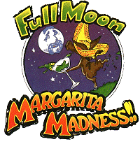
Salem NH , Nashua NH & Waltham MA locations!
5% of Lounge sales to go to DNH.
Event includes raffles and give-a-ways!
Join us for a HOWLING good time.
______________________
CIBC Miracle Day 2005
December 7th
See details online or call us for information!
_________________________________
Annual Valentines Dinner
February 11th 2006 5:30pm – 11:30pm+
Wyndham Hotel, Andover
Hors d'oeuvres, Balloons, Dinner, and
Silent Auction Event. Tickets available!

VOLUNTEERS NEEDED FOR:
Grant writing & Development
Event co-ordination
For more information or to volunteer to HELP, check out our web site.
http://www.devonshouse.org
or call our corporate office at:
603-594-1385




Krafts & NE Patriots Honor Co-Founder of DNH !
Mission: The Devon Nicole House is a non-profit 501(c)3 charity dedicated to providing a home-away-from-home for families that have children receiving care at Children’s Hospital Boston. We will continue to support The Devon Nicole House at Children's Hospital Boston and look to provide additional help to families in need.
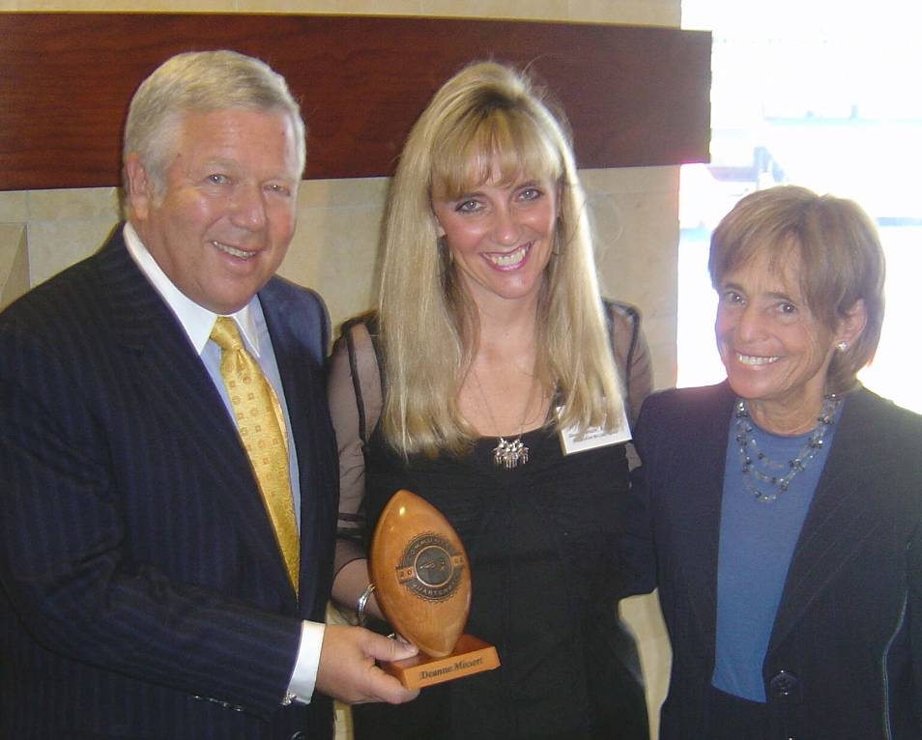
Bob and Myra Kraft present Deanna Missert with Patriot’s Community QB Award
Baby Steps .. by Devon’s Dad

The last year has flown by for all of us. The Devon Nicole House at Children’s Hospital Boston opened their doors and hearts just about a year ago. Since then over 300 families from across the US and over 7 countries around the world have stayed at the House.. The feedback and comments from the families staying at the House have been remarkable. YOU have helped to have a direct and positive impact on their lives during a tremendously difficult time. First and foremost I want to thank each and every one of you who have helped. A very special thank you goes to all of the Children’s Hospital and DNH staff and volunteers that have truly made the house become a home.

Word of the House and work done by the Board and founders seems to have begun reaching out into the community. Several weeks ago we were invited to nominate one of the DNH volunteers for the Patriots-NFL Community Quarterback Award. In talking with our Board members the decision to nominate Deanna was an easy one. She truly has poured her heart into DNH over the last 5 year. We were honored and humbled to be one of 20 charities that were presented with a trophy and a check from the Kraft’s and The New England Patriots Charitable Foundation on May 11th at a private luncheon. We were also blessed and honored over the last few weeks to be invited to talk with several groups that have supported DNH over the years including, District 29 Quota Club (picture page 2), Derry and Andover Rotary clubs, Hudson Kiwanis and Knights of Columbus Council (#685) of Raymond NH. Our hearts were also touched by the recent support we received from Windham NH Brownie Troop 2653 (picture page 2) who sold cookies to raise $100 for The Devon Nicole House.

The journey continues. We thank all of you again for your support. Without you, we could not reach out to help so many others. Please stay involved! We will need your continued support to continue our work. Right now we are actively looking for volunteers to help us with Grant Writing and Development. We also need several volunteers to help with the upcoming Golf Tournament and Valentine’s Dinner. If you’d like to help, please contact tom@devonshouse.org or call us at (603) 594-1385.

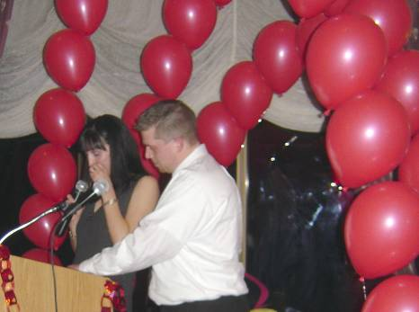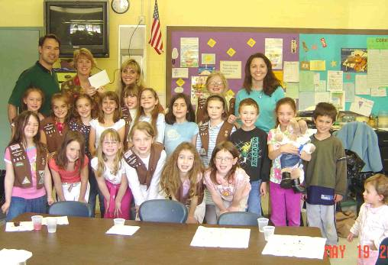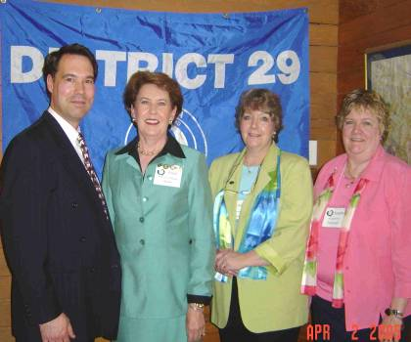
2005 Valentine’s Dinner Windham NH Brownie Troop 2653 Quota Club (Tom Missert, EnidCroes-
Miranda & William McDonald, speakers Golden Brook art room hosts troop donation Marugg, Linda Bonetti & Saundra Maisey)

5th Annual Valentines Dinner – Even with an unusually snowy and cold winter, over 180 attended the annual gala event helping to raise almost $20,000! The event included signature ice sculpture, Hors D’oeuvres, balloon sales and over 70 silent auction items up for bid. Guest speaker Cynthia Levin, Director for Center for Family Services at Children’s Hospital did a wonderful job conveying some of the statistics to date of people staying at The Devon Nicole House at Children’s Hospital Boston. The audience listened in silence as Miranda McDonald bravely spoke about her 2-year-old son Jacob’s first few days of life. Jacob was born with truncus arteriosus. Miranda shared a mother’s story of what the House and staying there meant to her and her family. Her speech touched the hearts of many people there. She was awesome.
Please join us for our 2006 Valentines Dinner at the Wyndham Hotel, Andover MA on Feb. 11th

Windham NH Brownie Troop 2653 – I can think of no better lesson to impart on our youth than a heart of giving and caring for others. Brownie Troop 2653 learned about The Devon Nicole House and decided to help by selling cookies to raise $100. The size of the heart and effort behind the gift truly touched us.

Quota Club District 29 Spring Conference – DNH Board Member Saundra Maisey continues to be a big advocate for The Devon Nicole House. As in-coming District 29 Governor, Saundra invited Tom Missert to update the Quota Club at their Annual Spring Conference. The Club presented a donation which brought District 29 and individual member gifts over the $1000 mark. Tom Missert had the opportunity to speak to members from Andover & Lawrence MA, Portsmouth, Dover and Manchester NH. Devon’s story also reached outside the US by touching Enid Croes-Marugg, Quota International of Aruba and International President-elect.

CIBC Miracle Day 2004 – CIBC Miracle Day generated over $14 million world wide on December 1st 2004. The Devon Nicole House was honored as one of 350+ children's charities selected to receive a portion of these funds. To leverage the 2005 event and allow DNH continue to help and serve families and their children we need your help. If you work at or have contacts within a financial firm that trades stocks, please contact us TODAY! (603-594-1385 or email tom@devonshouse.org)
Board of Trustees:
Thomas Missert Devon’s Dad, President Tom@devonshouse.org
Deanna Missert Devon’s Mom, VP Deanna@devonshouse.org
Ruth Adams Senior Member, &Treasurer Ruth@devonshouse.org
Jennifer Pontzer Senior Member, Board of Trustees Jennifer@devonshouse.org
Denise Tarquinio Senior Member, Board of Trustees Denise@devonshouse.org
Margaret DeSantis Senior Member, Board of Trustees Margaret@devonshouse.org
Gene McGraw Senior Member, Board of Trustees Gene@devonshouse.org
Karen McHugh Senior Member, Board of Trustees Karen@devonshouse.org

Please Welcome to the Board:
Saundra Maisey Senior Member, Board of Trustees Saundra@devonshouse.org
Therrin Allen Senior Member, Board of Trustees Therrin@devonshouse.org
Monica Baird Senior Member, Board of Trustees Monica@devonshouse.org

PLEASE NOTE: We are currently looking for 3 additional Trustees to help us in our next phase of growth. Please call Tom if you would like to be considered for a Trustee position or would like to volunteer as an advisor to the Board.

Advisors to the Board:
Dr. Jim Lock Physician-in-Chief and Chairman, Dept of Cardiology Children’s Hospital Boston
Dr. Kathy Jenkins Cardiologist, Children’s Hospital Boston
Susan Shaw Director Clinical Operation, CHB
Cynthia Levin Director Center for Family Services CHB
Scott Neely Executive Director, Neely Foundation
Ian Hoenisch CTO, ESP Technologies
Dick Cyr President of David’s House, Lebanon NH
Laura Sol Sr. VP, American Heart Association
Vinny Harte Director, Wellspring Inc, Hull MA
Suzanne Mooney former Board Member of Jason’s Place
Dean Ouellette High Street Communications
Santa Sasena Price Waterhouse-Coopers
Dr. Anne Jacoby Cardiovascular Nurse Specialist
Paul Henry American Express Financial Advisor
Tracy Jenkins Special Events Assistant
Jae-Ann Rock Development and Events
Richard Defalco Former member of DNH Board

Margarita's Full Moon Madness

Thursday, July 21 Friday, August 19 Sunday, September 18
3 locations Salem NH, Nashua NH and Waltham MA.
PLEASE come join us for some great times and AWESOME food!

How It Works
Every month, on the night of the full moon, Margarita Restaurants across New England throws a big party in honor of a charity and give back to the community. During that party they have giveaways, contests and lots of fun. Most importantly, five percent of the entire evenings' gross lounge sales are donated to a local charity. The Devon Nicole House has been blessed to be selected as a recipient charity of 3 restaurants in Q3 of 2005. PLEASE mark your calendars today and come join us for a great evening of fun
and some awesome food.
4th Annual Charity Golf Tournament for The Devon Nicole House

Thursday 12 pm June 16th 2005
DAYS SCHEDULE
Sheraton-Ferncroft Country Club, Danvers MA 12:00pm Registration & Golf range opens.
$200 fee covers the entire event including: 12:30 –1:30pm Lunch
Lunch, 1 bucket of balls at the range, greens fee & cart 1:30 pm Shotgun start, BRAMBLE PLAY
player's pack (5 raffle tickets and player gift) 5:30– 6:30pm 19th Hole. Reception/Cocktail Hour
and dinner.
AUCTION INCLUDES: Red Sox vs. Yankee tickets, 1pm-7pm Silent Auction
Calloway Irons, 4-somes, Vacation trips, and much more!! 6:30pm-9pm Dinner, awards and update on DNH.
(Check website for full list on Monday June 13th)

At this year’s event we will also be celebrating the 1 year anniversary of DNH at CHB being open!!

Please circle one or feel free to call us to discuss playing, sponsorship or volunteering to help:
Player | Hole or Green Sponsor | Team | Team, Green & Hole Sponsor | Dinner/Lunch Sponsor  (Includes 1 team) | Major Sponsor  (Includes 1 team, signage, ads and PR) | Other  Donation;
$200 | $200 | $800 | $1000 | $2,500 | $5000 | Write in or call:

Payment (circle one): Visa – MasterCard - Check Total: _____________
Please FAX this page to
603-594-8849

We will call to confirm.
Thank you for your support!

Please Print
Name as it appears on card _______________________________________________

Billing address__________________________________________________________

_____________________________________________________________________

Telephone: (________)_______________________ email: _____________________________________

Card Number__________________________________________________ Expiration__________________

I authorize DNH to debit my card as specified above____________________________________ (Signature required)

You are cordially invited to attend the
6th Annual Valentines Charity Dinner
for The Devon Nicole House

Saturday, February 11, 2006

Location: Wyndham Hotel, Andover MA.
Main Ballroom.

Event: Romantic and Elegant Valentines Dinner plus Silent Auction.
Charity event with proceeds to help us support
The Devon Nicole House at Children’s Hospital Boston.

Price includes: 5:30pm-6:30pm Reception with Hors d'oeuvres. Balloon sales.
6:30pm-11:30pm+ Formal dinner, drinks, entertainment,
dancing and entrance to the Silent Auction.

Pricing: Seating is $75 per plate. Tables seat 8-10 people.
Corporate Sponsors are needed. Please call us for details.

__________________________________________________________
Please contact us if you are interested in Tickets. Call 603-594-1385 OR fill out this form and send it to us.
Please FAX this page to
603-594-8849
OR
If paying by check, mail to:

Devon Nicole House
PO Box 901
Londonderry NH 03053

We will call to confirm.
Thank you for your support!

Payment (circle one): Visa –MasterCard - Check

Please Print
Name as it appears on card ______________________________________________

Billing address________________________________________________________

____________________________________________________________________

Telephone: (________)__________________________ Number of tickets _____

Email: ______________________________________ Total: ___________

Card Number_________________________________________________ Expiration__________________

I authorize DNH to debit my card as specified above____________________________________ (Signature required)

(* If you can not attend but would like to make a donation, please list pledge here $________ and FAX us this form)

OR Log on to our website for event details, directions, or more order forms: www.devonshouse.org

Memorial donations were given to DNH in loving memory of:
Nathan Cummings Devon Nicole Missert Clare Elizabeth Ettrick
Janet Huminski Olivia Joy Tarquinio Robert Carr
Lucas Richard Dalke Daniel Joseph Hyatt Katelyn Rose Pacheco
Mary Perkins Bernice Smith Thomas Allen Abbott III (Tripp)
Darrell Dupree Theodore Cotrupi Eileen Keefe
Muriel Tyler Adam Bryce Craig Anna Grace Garafola

Donations were made in Honor of the following people:
Jacob McDonald Paige Aitken
Shane Mulcahy Elizabeth Allen
Barry Condron John & Linda Callahan

Due to the overwhelming support and donations we simply ran out of room and time needed to list all those that have made donations. Each of you should have received a note thanking you for your support.
From the families and DNH Board of Trustees, Thank You, again.
Truly, without you.. The Devon Nicole House would still be just a dream.

To all those that donate to
The Devon Nicole House
(YOU know who you are)
THANK YOU!!

Your support has had a direct impact on the lives of the families staying at The Devon Nicole House at Children’s Hospital Boston. With your help we have:

- Paid a second half of the $300,000 to help with renovations of 21 Autumn St. 5th Floor. Home to The Devon Nicole House at Children’s Hospital Boston.
- Donated $55,000 since the Spring of 2004 toward the operations of DNH.
- Made the first DNH Grant to the Brito-Peña family for $2025
(* More information on how to apply for a DNH Grant is available online at : www.devonshouse.org )
- Purchased 6 additional cots for families staying at DNH
- Provided numerous meals and donated box loads of lotions, soaps, and shampoos
- Donated cartons of food and cases of coffee
- Purchased 10 color TV’s with DVD players for the rooms at DNH
- Bought 15 fans for rooms at DNH
- Helped provide a home and place of comfort for more than 300 families from over 24 states across the US and over 7 countries internationally.
The Devon Nicole House
PO Box 901
Londonderry NH 03053
PRESORTED STANDARD
POSTAGE & FEES PAID
LONDONDERRY, NH
PERMIT NO. 60

To:

DNH Critical Needs:
- Donations at all levels
- 2-3 volunteers to help with Grant writing
- 3 new members for DNH Board of Trustees
- Volunteer to help with fund-raisers
- Continued Prayers
- Annual Endowments for on going operational costs to support DNH
- Members for Advisors to DNH to provide on going support and guidance to the Board of Trustees
- DONATED ITEMS FOR SILENT AUCTION
for Valentines Dinner, February 11th 2006
AUCTION IDEAS: Event tickets, RCI vacations, autographed sports memorabilia, dinner gift certificates, golf lessons, quilts, TV, digital camera, gift baskets etc.
WISH LIST ITEMS FOR THE HOUSE:
- Quick pre-packaged meals & snacks
(Mac&Cheese, granola bars, frozen dinners, chips etc.)
- Phone Cards, movie passes, T-cards
- Deliver a home made meal (call for info)
- DVD’s (Kids and adult G/PG movies)
- Dinner gift certificates
- Assorted sample sized toiletries
(soap, lotion, shampoo, conditioner etc.)
- Laundry detergent, fabric softener, etc.
- Kitchen items (Plastic/paper)
(plates, cups, napkins, towels, utensils, Ziplock bags, etc.)
- Magazine & Newspaper subscriptions
(People, Newsweek, USA Today, WSJ, BBJ Globe, Herald, etc.)
- NEW stuffed animals, baby blankets

